1. Find the number of students who scored less than 5(50%).

//DATA LOAD

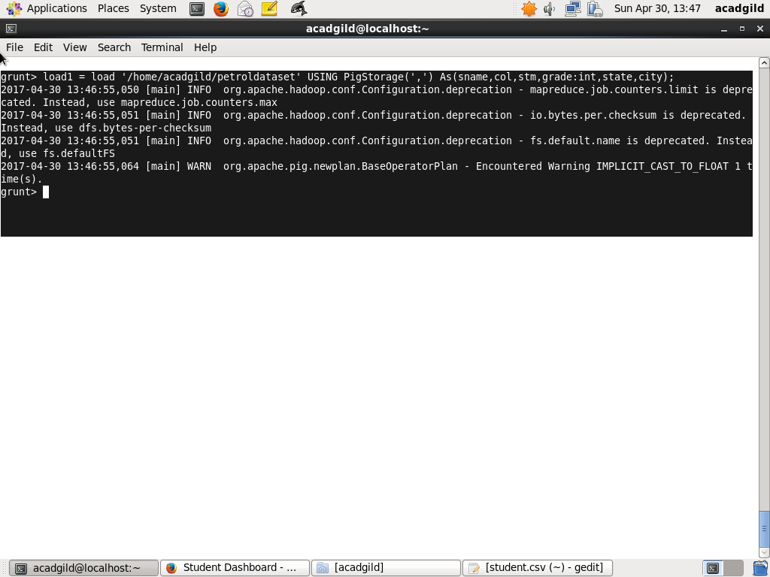

//QUERY EXECUTION

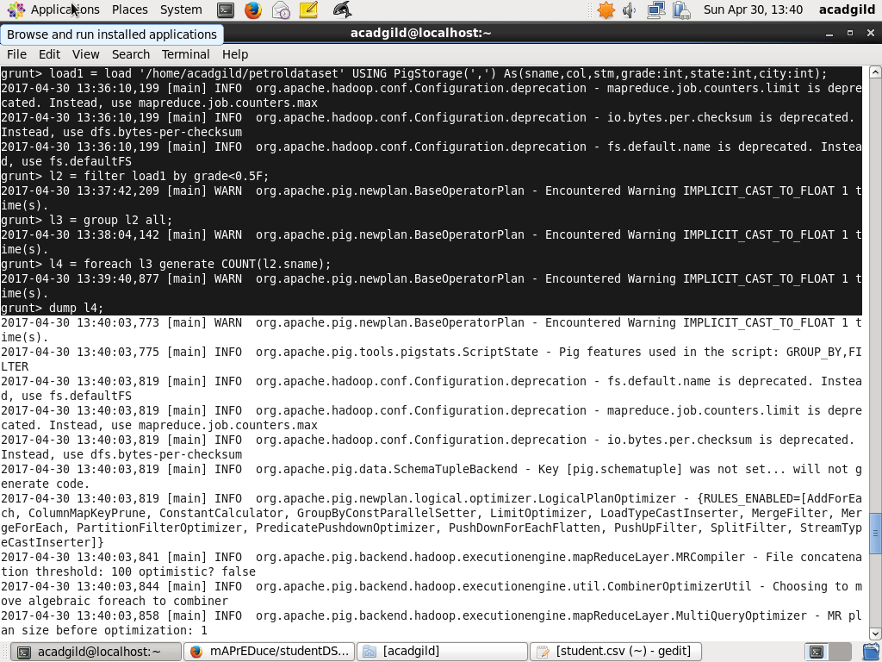

//RESULT

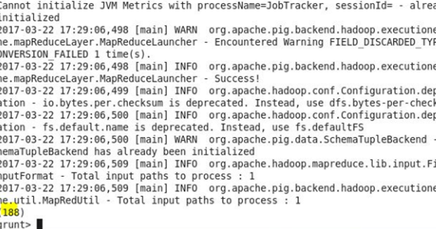

1. List the name of students who are from Alaska.

//DATA LOAD



//QUERY EXECUTION

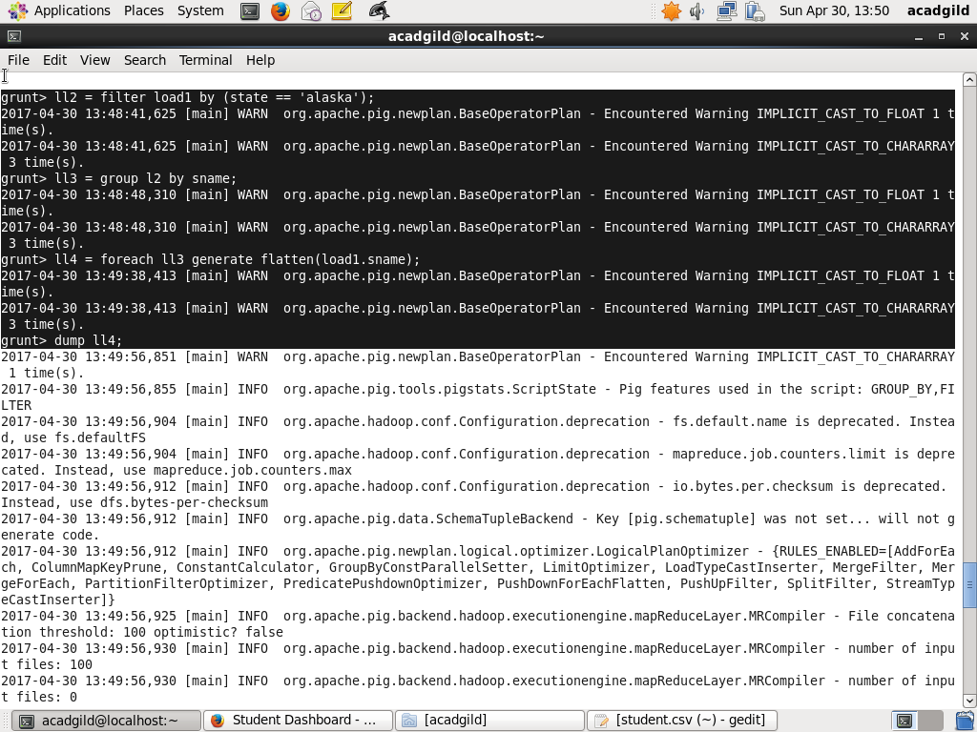

//RESULT

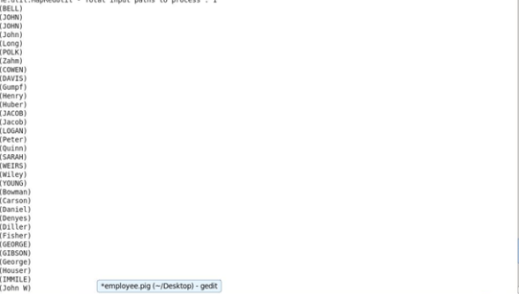

1. How many government colleges are there in Alabama?

//DATA LOAD



//QUERY EXECUTION

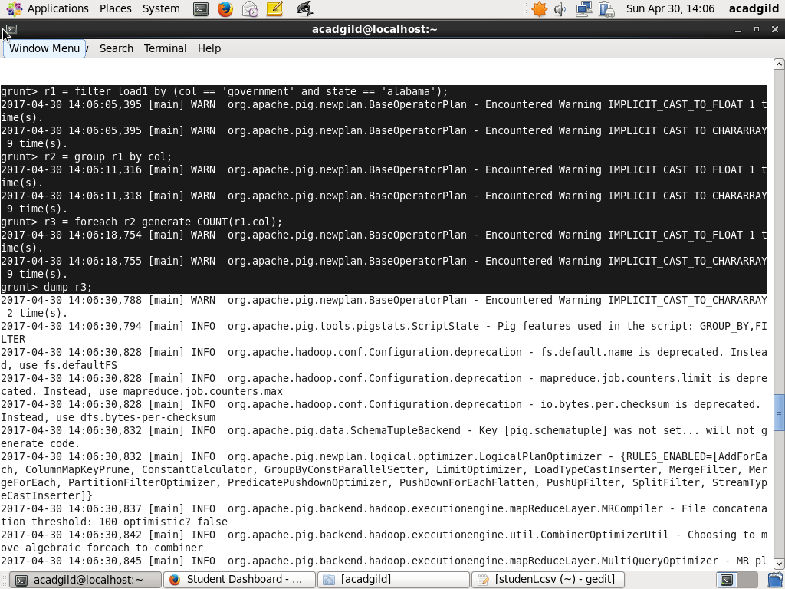

//RESULT

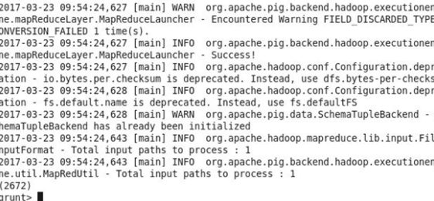

1. List the name of students who are from Oregon and pursuing BE.

//DATA LOAD



//QUERY EXECUTION

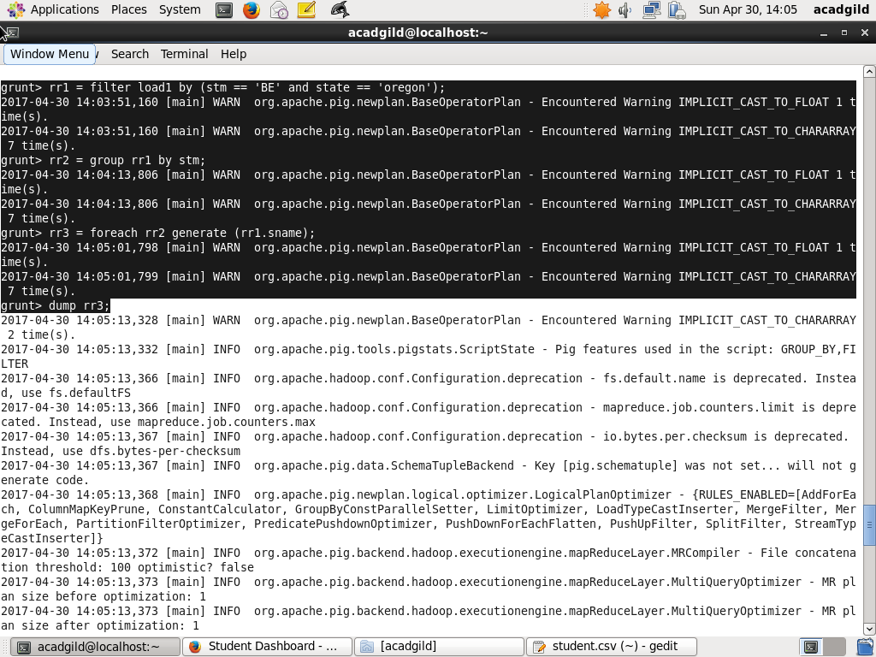

//RESULT

